**Writing with lines and pictures – Language Activity**

Most people in ancient Egypt did not know how to read or write. This meant they would have to visit a scribe if they wanted to send a letter, which would be written on a thick type of paper made from papyrus reeds.

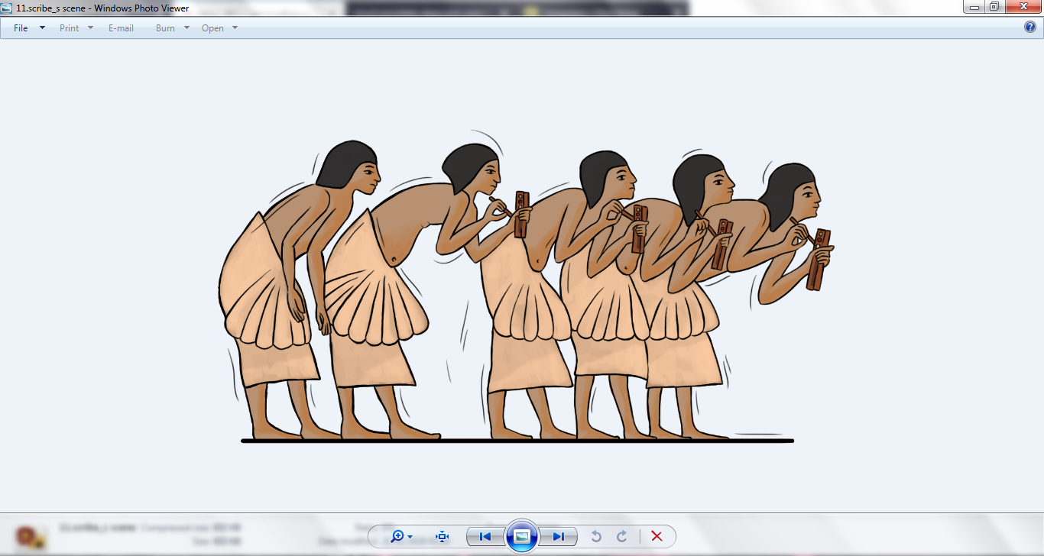

Only the rich could afford to send their children to school to become scribes. Scribes did most of the writing in ancient Egypt but other important people like priests and the royal family also learnt how to read and write.

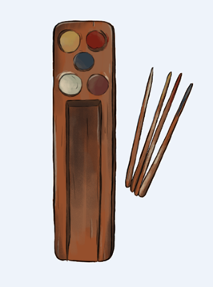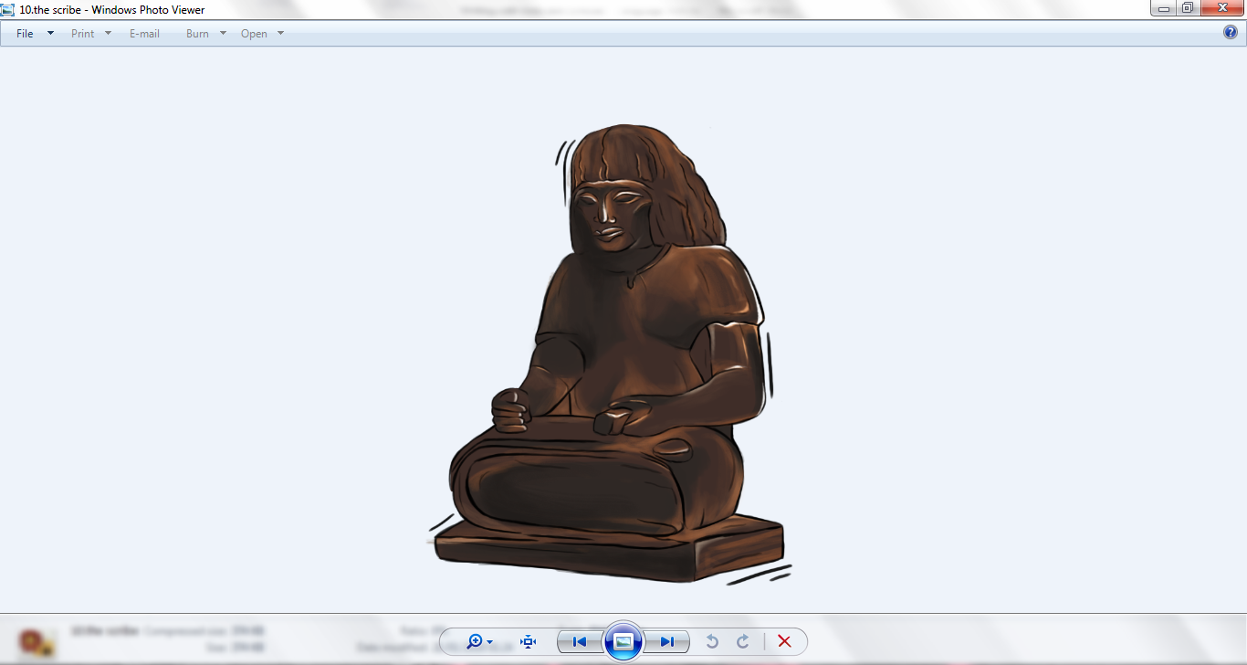

There were two forms of Egyptian writing in use when Amarna was Egypt’s capital city. The first was hieroglyphs. Some hieroglyphs look like pictures of the thing they stand for. Can you see how the hieroglyph for an old man looks just like an old man, how the house looks like a drawing of a house and how the hieroglyph for water looks like waves in the water?

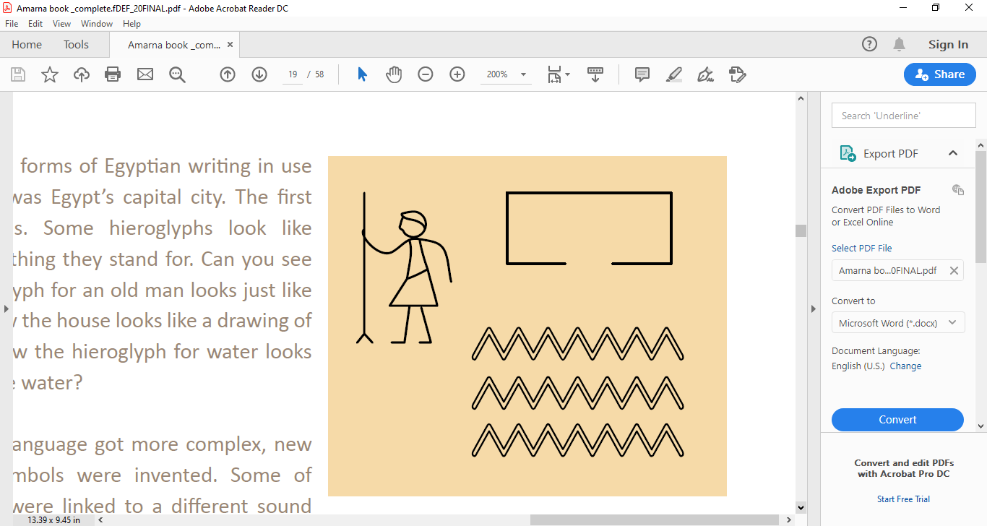

As the written language got more complex, new hieroglyphic symbols were invented. Some of these symbols were linked to a different sound or even a few sounds. Other new symbols had no sounds connected with them at all but were used as visual signs to help explain the full meaning of a word.

Hieroglyphs weren’t always written one after the other as would seem logical to us today – they were often grouped together. It was a very complicated language!

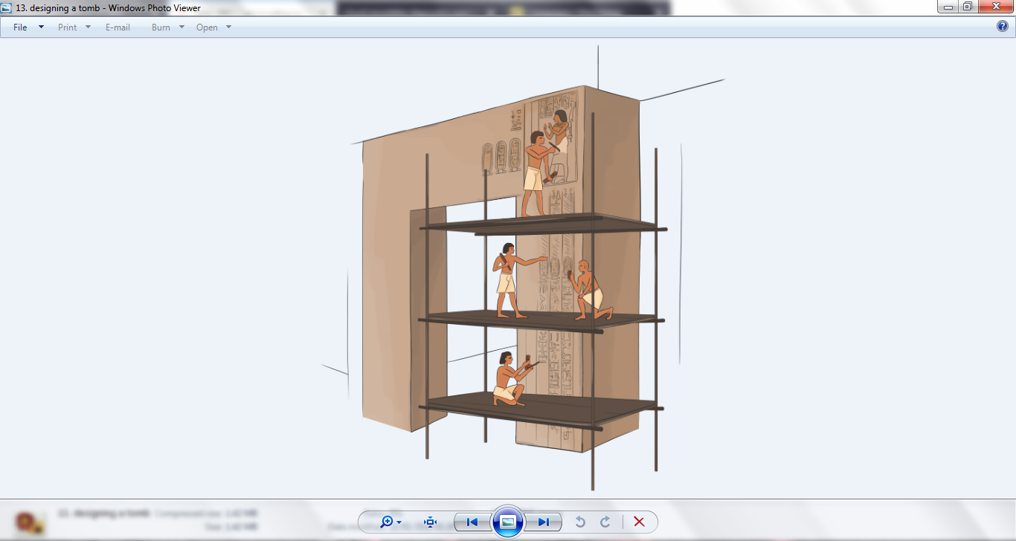Hieroglyphs were mainly used in monumental buildings and rich people’s tombs.

Hieratic was used for more everyday tasks like writing letters and managing the business of the King. Hieratic was based on hieroglyphs but was much faster to write as the shapes were simplified.

Can you see the similarities between the top line which is in hieratic and the bottom line which is in hieroglyphs? Have a go at copying them both and see which one you can write the most quickly!



Hieroglyphs and hieratic are no longer used in Egypt or anywhere else in the world. In fact, the knowledge of how to read these scripts was forgotten for more than 1000 years!

A form of the ancient Egyptian language survived as Coptic, which is still used in the Egyptian Christian church. Coptic is written using the ancient Greek alphabet with a few extra signs.

Around 200 years ago, when people became really interested in ancient Egypt, the ancient language had to be cracked like a secret code! The puzzle of the hieroglyphs was finally solved in 1822 by a Frenchman called François Champollion.

**Language Challenge!**

Can you decipher these simplified hieroglyphic names using the different letters and sounds shown in the table below?

Each group of symbols spells the name of a famous person from Amarna! Each name is written inside a cartouche.

A cartouche is an oval shape with a line at one end, which was usually only used to enclose the names of royalty. At Amarna the god Aten had his name written in cartouches too!

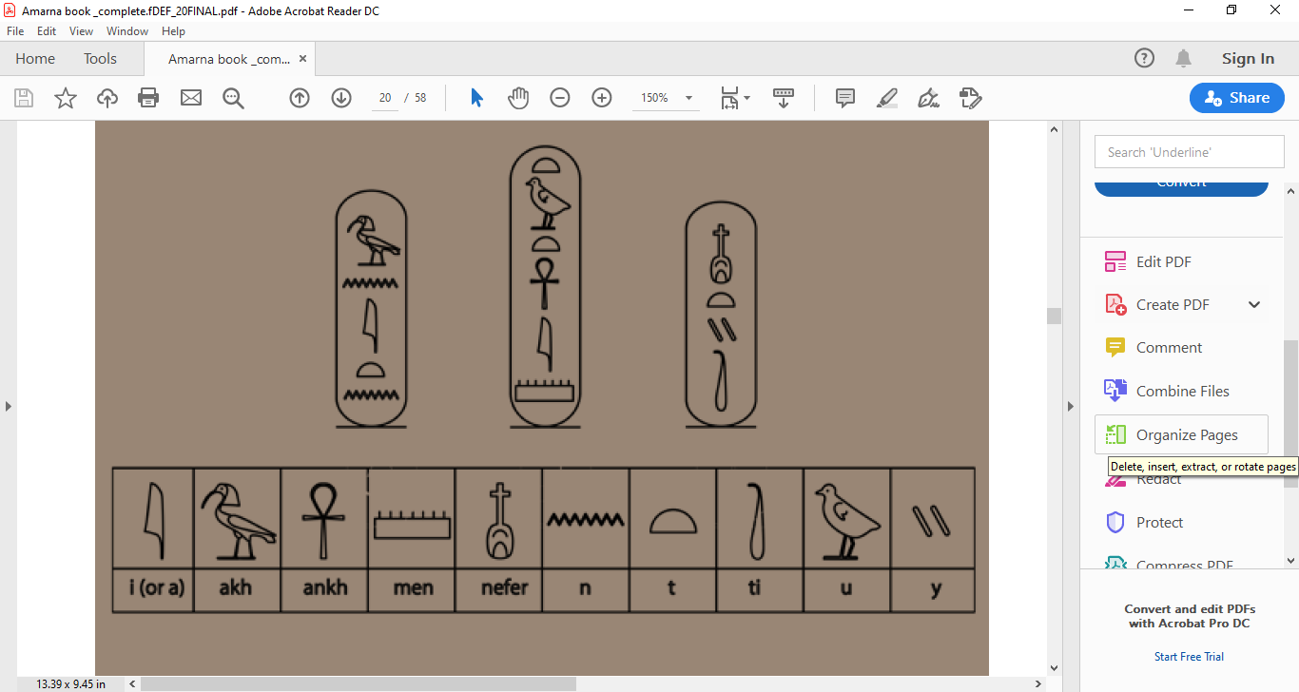

Translation tip! English is always written from left to right – Hello. Arabic is always written from right to left – مرحبا. Hieroglyphs could be written from left to right, right to left, or top to bottom. The only way they could not be written was from bottom to top!

When the cartouches for these three important people were written out in full, they had lots of extra symbols and sometimes parts of the names were moved around. This shows you just how difficult it was to learn to spell in ancient Egypt! Can you figure out which cartouches match the ones you have just deciphered?

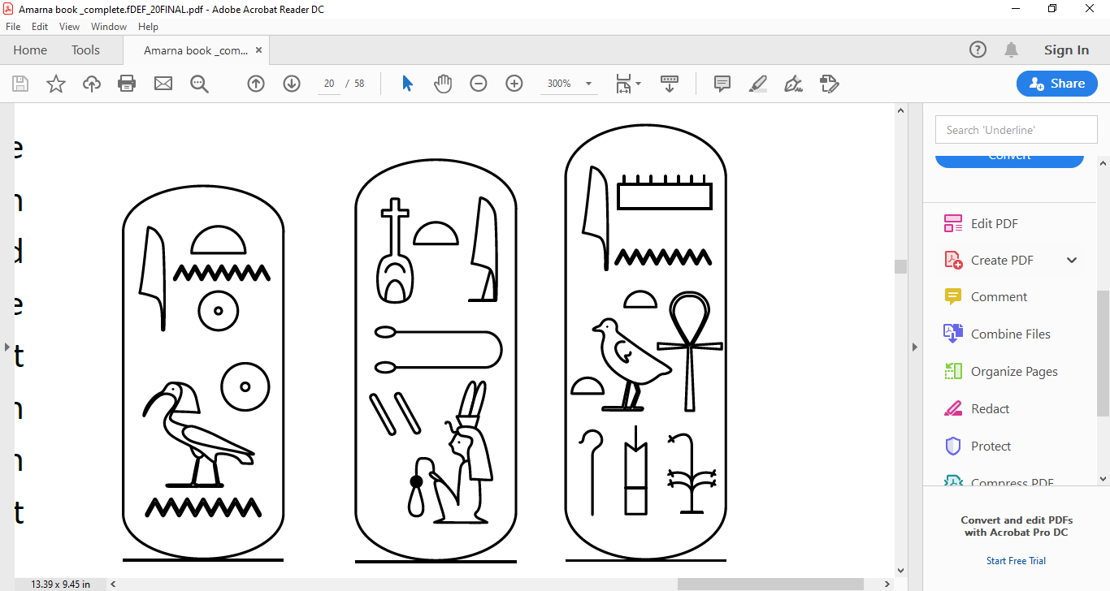

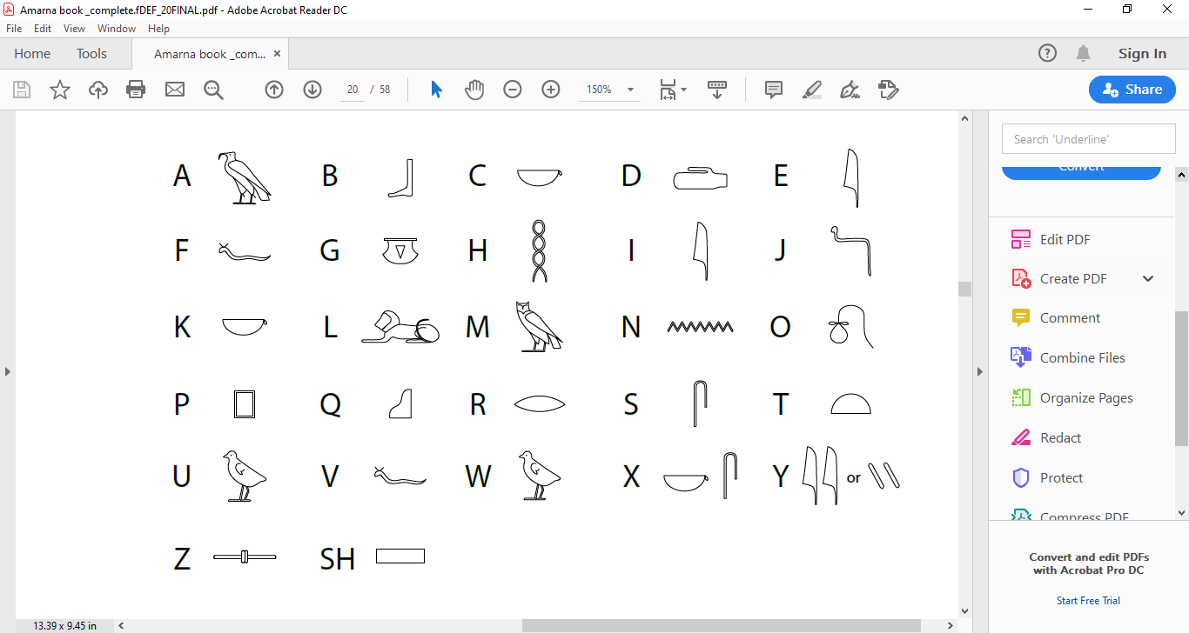Can you spell out your name in simple hieroglyphs?