**Fabric and Fashion: Design and Technology**

Just like today, clothes and other textiles (fabrics) were important in all areas of ancient Egyptian life. At Amarna we can tell a lot about the things people wore by looking at scenes from tombs and temples. Archaeologists also find the remains of many different textile items when they excavate houses and graves.

Linen, which is made from a plant called flax, was the most widely used cloth in ancient Egypt. Sheep’s wool, goat hair and fibres from the bark of palm trees were also used to make fabric

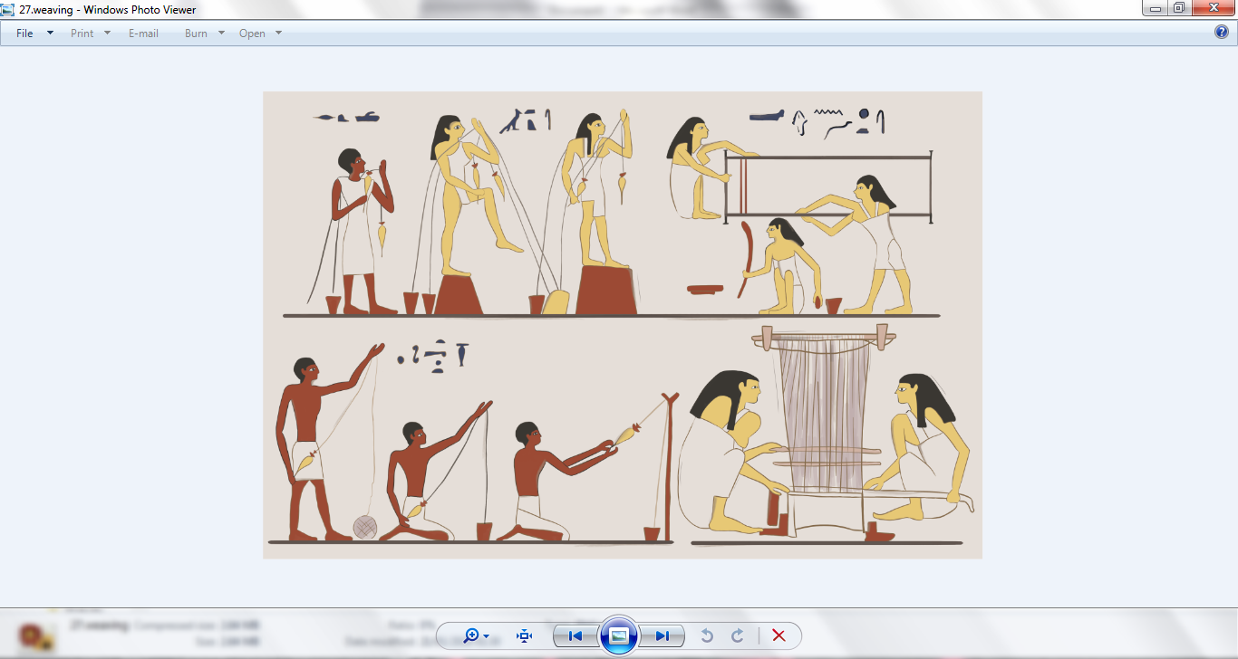

Thread or yarn was made from plant or animal fibres by spinning. This involved twisting lots of the thin fibres together to make longer and thicker strands. The thread was then wound into balls. The thread was sometimes bleached to make it white by washing it and drying it in the sun. It could also be coloured using dyes made from plants and other natural materials, but most clothes were made from undyed and unbleached thread. Once the thread was ready, it could be woven into cloth on a loom (like in the picture above and on the next page!).



A loom is a large weaving tool. Long threads are fixed between either ends of the loom. Thread is then passed under and over these fixed strands to create an interlocking mesh called a weave.

Today we use machines to weave cloth, but in ancient Egypt this was done by hand. There were two main types of loom at ancient Amarna. One could be used in an upright position fixed into blocks set into the floor or leant against a wall. Another ran along the floor and was fixed into wooden beams raised just off the ground. The upright loom was popular in ancient Amarna because it was good for making larger pieces of fabric. This created a new fashion for pleats and folds in the clothes of the rich.

At ancient Amarna, fabric was made in workshops as well as in people’s homes. Kilts were popular with wealthy men, while women from rich families often wrapped themselves in a large piece of cloth that was held in place by a knot or belt. Sometimes the clothes of the wealthy were pleated and fringed, or even dyed or woven in bright colours.

Men and women from poorer families in ancient Amarna would have all worn simple bag-tunics. These were made from large rectangular pieces of cloth, folded over and stitched up the sides. A slit or keyhole-shape would be cut in the top for the head. When working in the fields, men would have worn loin-cloths (a sort of triangular-shaped underwear). Young children often would have gone about unclothed in the warmer months! When they reached about eight years old, they started wearing the same style clothes as their parents.

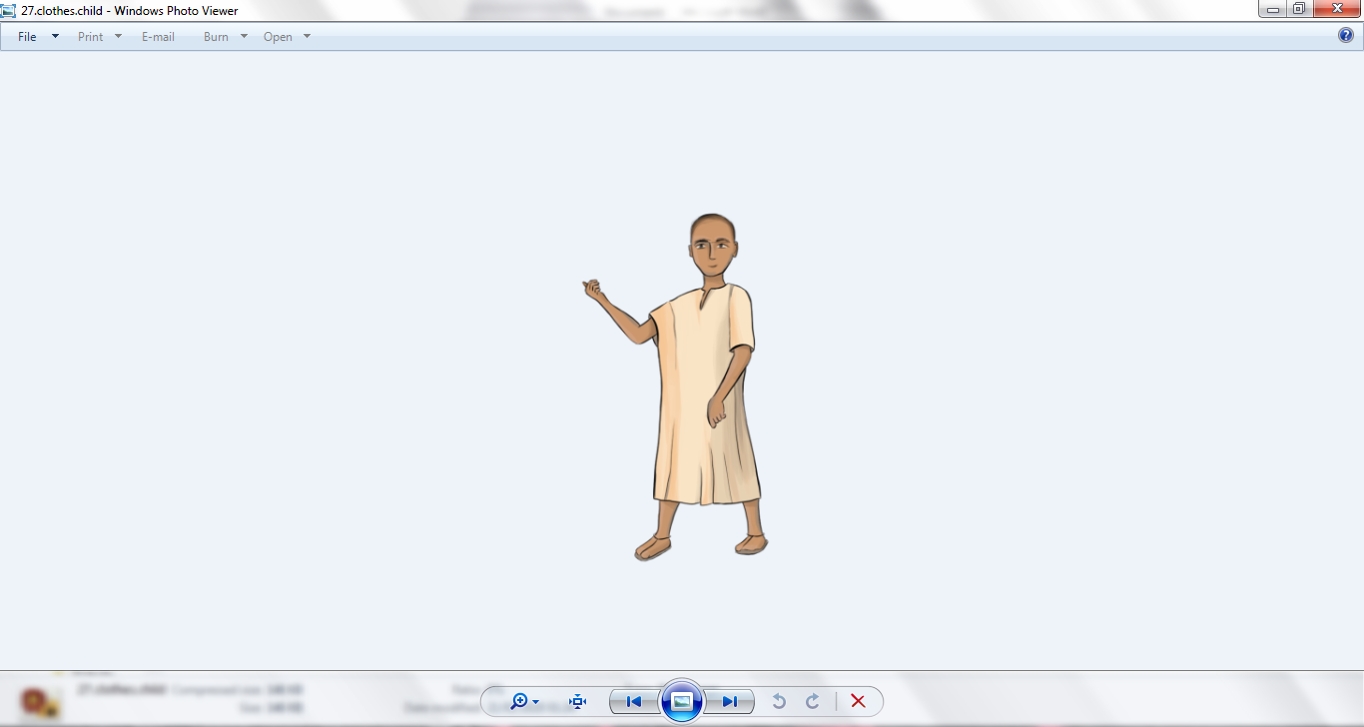 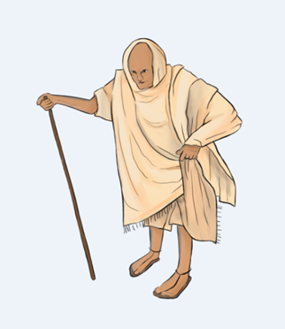 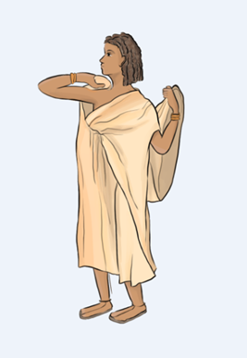

Many people in ancient Amarna were very poor and probably didn’t wear anything on their feet! Those who could afford it wore sandals made from leather, date palm leaves and grasses.

**Design and Technology Challenge!**

Why not have a go at weaving your own cloth?

What you’ll need:

- 1 small piece of hard cardboard (like from a cardboard box, 12cm x 12cm square is a good size but you can go bigger!)

- pen or pencil

- scissors

- 1 small ball of wool or thread, or several long lengths of different coloured wool or thread

- ruler

- sticky tape

- needles (these aren’t essential as explained below)

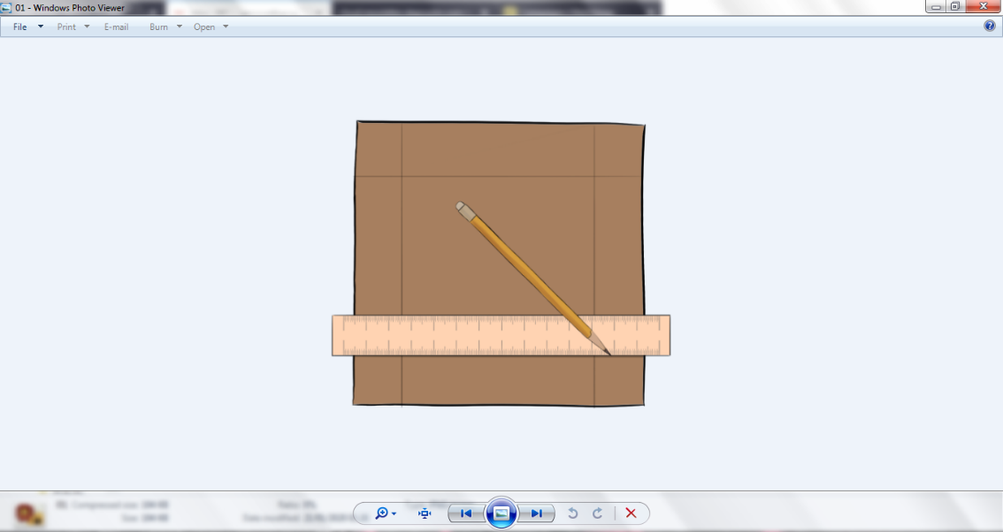

Step 1. Use your ruler to draw a border at the edge of your card, around 2 cm in from each side of your loom.

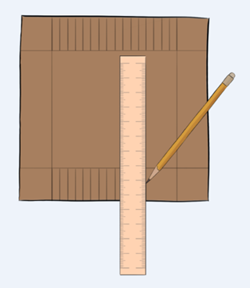

Step 2. On two opposite sides, draw lines for the notches. These should be around 0.5cm apart and reach all the way across the loom from between your 2cm marks and the edge of your card.

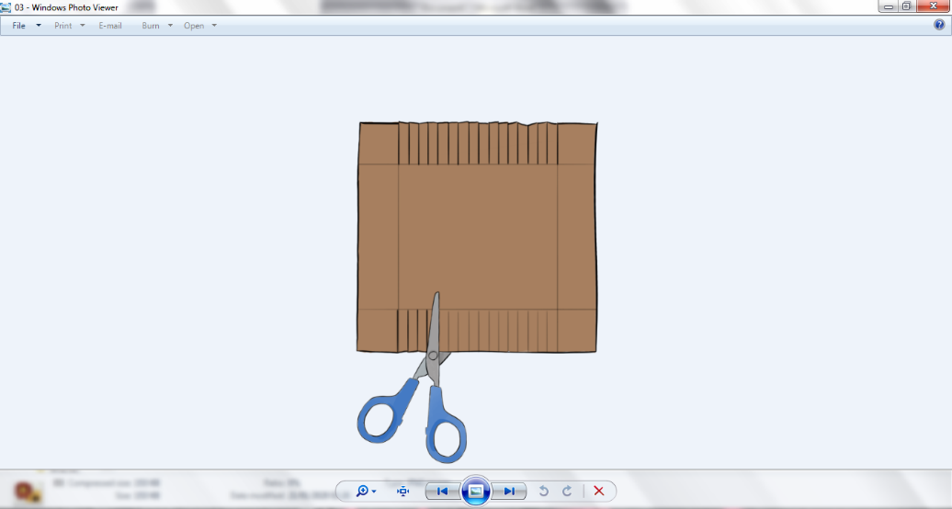Step 3. Carefully cut along the lines you’ve drawn for the notches, stopping at the border line.

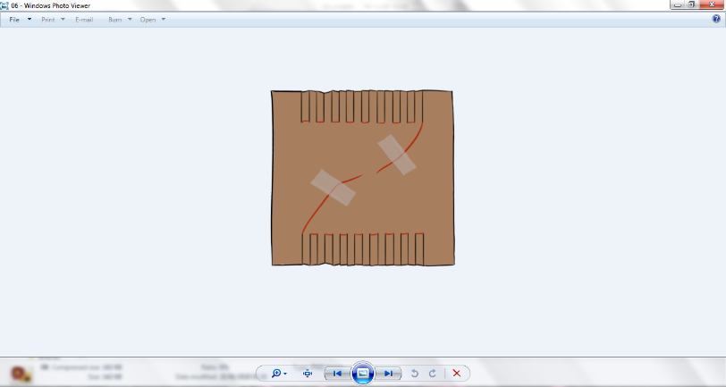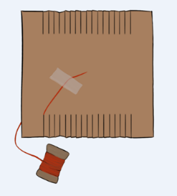Step 4. Tape the end of one strong thread to the back of the loom (the unmarked side). Pass the thread through the first notch at the top left of the card and wrap it over the front of the loom and through the opposite notch at the bottom of the card. Continue doing this all the way across the loom (like in the picture) and tape it to the back.

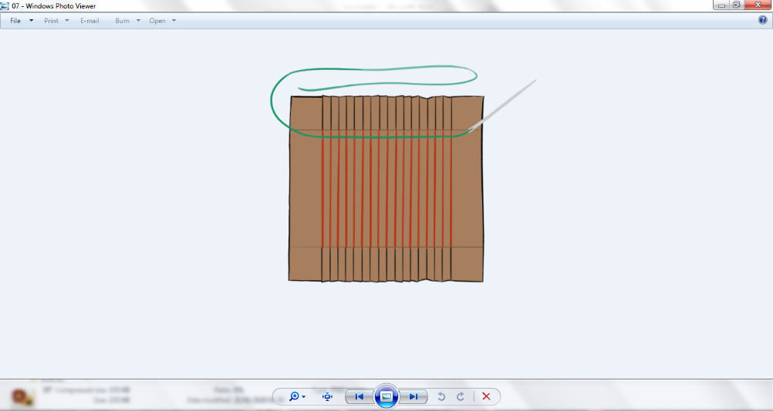Step 5. Cut a new length of thread (around 2 cubits long). You can either attach the thread to a needle (and make a knot so it doesn’t fall out), or wrap a small 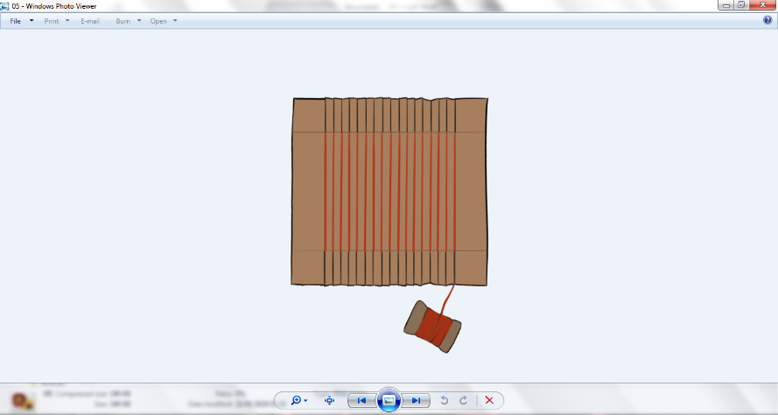piece of tape around the end of the thread – making it more solid – and weave with it directly.

Step 6. Guide the thread through the loom in an under-over pattern. Go under the first string, over the second, under the next and so on until you reach the other side of the loom. Pull the thread through leaving around 5cm sticking out the end. Push the thread up to the top of the loom towards the notches.

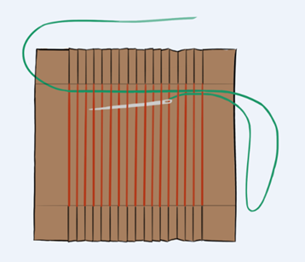Step 7. Bring the thread back through the loom from the side you just exited. This time you need to use the opposite pattern compared with your first line. This means you need to start the second line by going over the top of the first string if you just went under it, or by going under it if you just went over it. Continue the under-over or over-under pattern until you reach the other side. Pull the thread through but not too tight so it doesn’t bend the string of the loom! Push the second line of thread up to meet the top row.

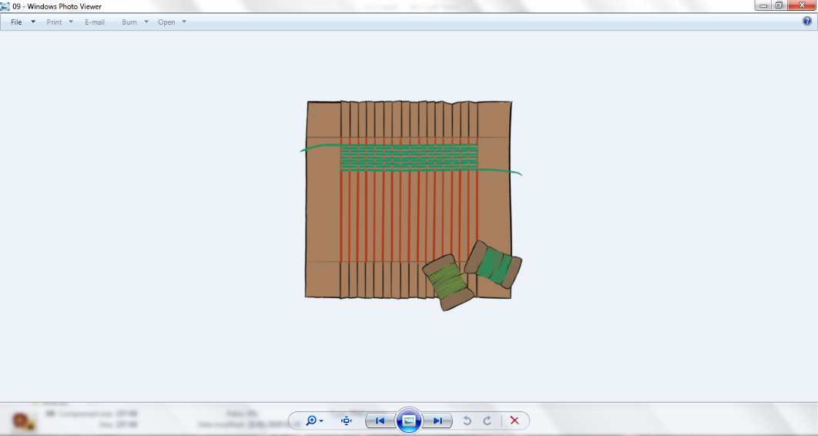Step 8. Keep adding new rows by alternating the over-under pattern and don’t forget to push the thread up so that each thread touches.

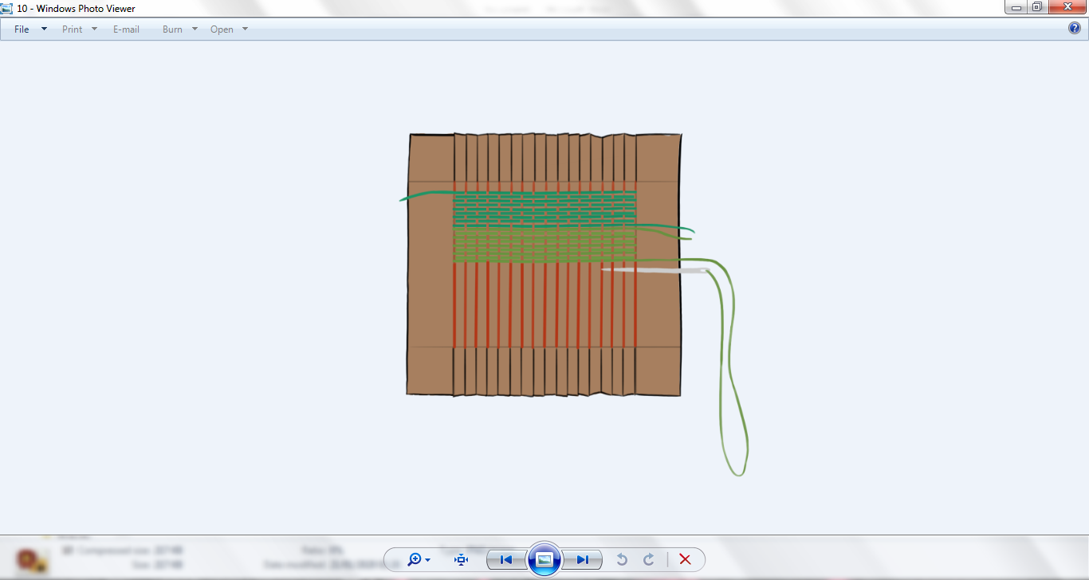Step 9. If your thread runs out or you want to add a new colour, you can add a new thread. Leave a tail on the side of the loom the thread finishes. On the same side, add the new colour just like you did in Step 6. Make sure you’re continuing the correct under-over or over-under pattern and carry on weaving.

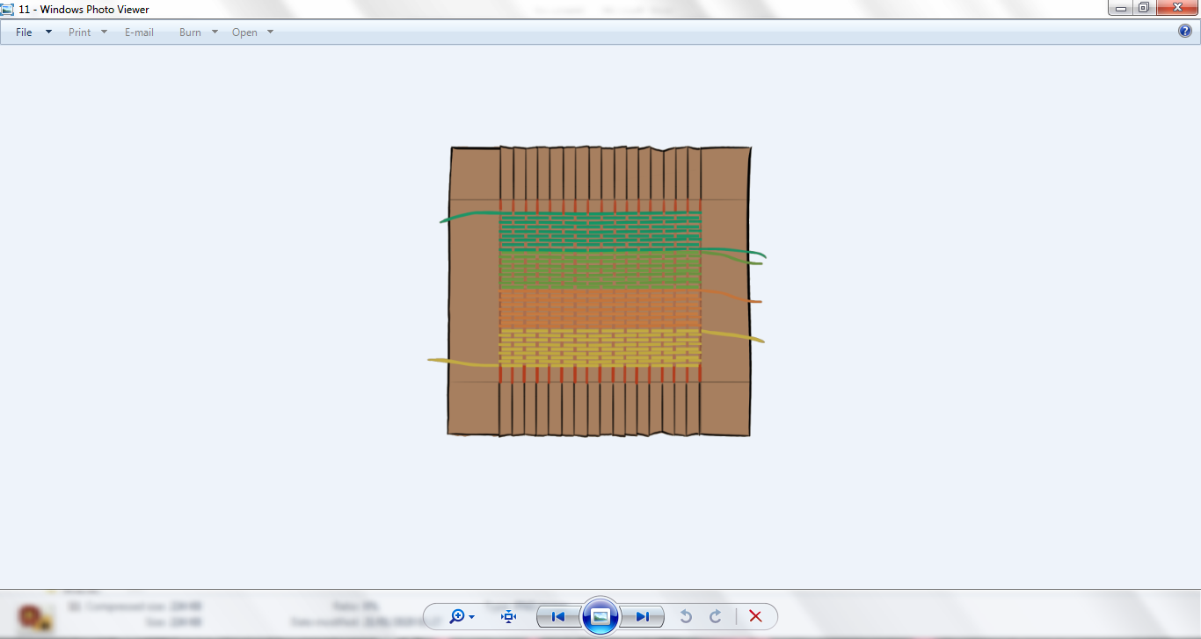Step 10. Once your loom is full, you can tidy up the loose ends by threading them back inside the weaving a couple of centimetres down the side of the support threads. Then pass the thread back to the outside, pull it tight and cut off the rest of the tail.

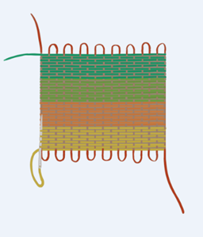Step 11. To finish your weaving, remove the tape from your original thread on the back of the loom and unhook it from the notches. Push the weaving down onto the bottom loops as far as it will go. Now you have longer top loops. Cut these in the middle and tie the two ends together neatly. Finally, tie the two long ends that were taped to the back of the loom neatly to the nearest under-over, over-under woven thread and tuck the end inside of your weaving like in Step 10.

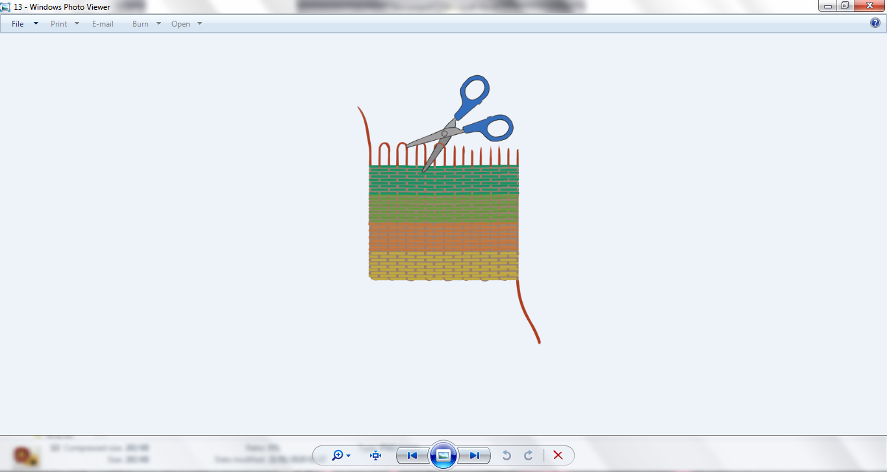 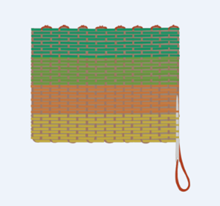

You’re done! What might you do with your finished product?