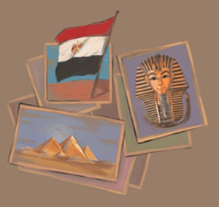
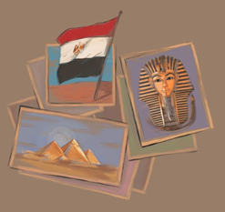
Timeline of Egypt

Predynastic Period 4800–3100 BC

Dynasty 0 3100–3000 BC

Early Dynastic Period

Dynasty 1 3000–2800 BC
Dynasty 2 2800–2675 BC

Old Kingdom
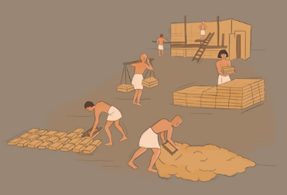
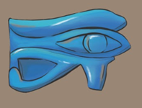
Dynasty 3 2675–2625 BC
Dynasty 4 2625–2500 BC
Dynasty 5 2500–2350 BC
Dynasty 6 2350–2170 BC
Dynasties 7–8 2170–2130 BC

First Intermediate Period 2130–1980 BC

Middle Kingdom

Dynasty 11 (after reunification)1980–1938 BC
Dynasty 12 1938–1759 BC
Dynasties 13–14 1759–1630 BC

Second Intermediate Period 1630–1539 BC

New Kingdom

Dynasty 18
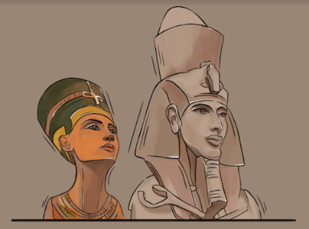
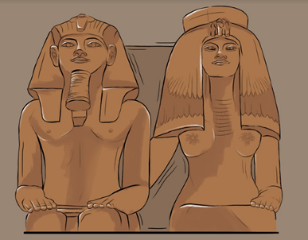
Ahmose 1539–1514 BC
Amenhotep I 1514–1493 BC
Thutmose I 1493–1482 BC
Thutmose II 1482–1479 BC
Thutmose III 1479–1425 BC
Amenhotep II 1426–1400 BC
Thutmose IV 1400–1390 BC
Amenhotep III 1390–1353 BC
Akhenaten 1353–1336 BC
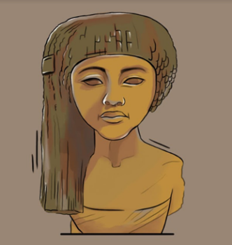
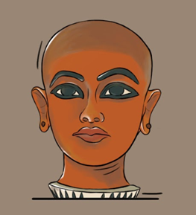
Dynasty 18 continued
Neferneferuaten & Smenkhkare 1336–1332 BC
Tutankhamun 1332–1322 BC
Ay 1322–1319 BC
Horemheb 1319–1292 BC
Dynasty 19 1292–1190 BC
Dynasty 20 1190–1075 BC

Third Intermediate Period 1075–656 BC

Late Period 664–332 BC

Ptolemaic & Roman Periods 332 BC–642 AD

This section follows Freed et al. Pharaohs of the Sun, p. 13. Note that Egyptian chronology is not perfectly fixed and the start and end dates of kings’ reigns should be considered somewhat flexible.

Arab Conquest of Egypt 642 AD

Cairo becomes Egypt’s capital in 969 AD

Mameluke Period 1250–1517 AD

Turkish Ottoman Period 1517–1882 AD

British Colonial Period 1882–1922 (although British influence continues until 1953)

Egypt becomes a Republic 1953–present day

