**Producing Patterns – Art and Design Activity**

The style of art at ancient Amarna was very special. The use of softer, rounder shapes and attention to detail made images seem more alive than in earlier times. Akhenaten and his family embrace each other, like in a family photo. Marching soldiers, whirling dancers and people on speeding chariots look as if they might pop out of the painted scenes at any moment! Plants and trees seem to sway in the breeze. Birds look ready to flap their wings, horses appear ready to gallop and calves leap through the river rushes.

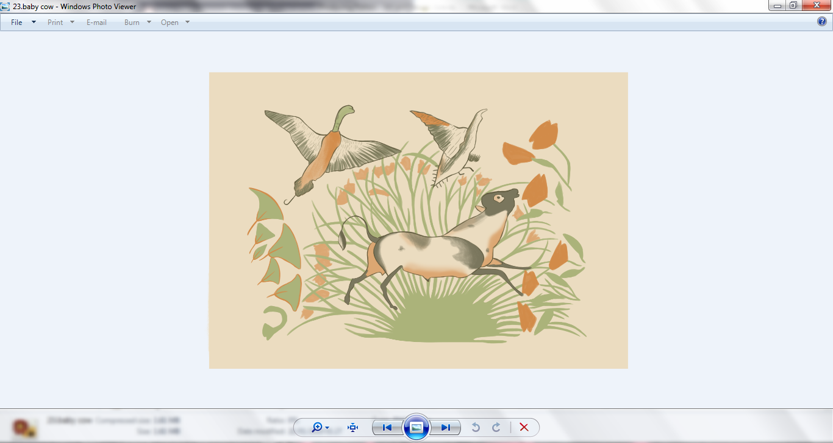

Plants, birds and animals were very important to the ancient Egyptians. They showed the life-giving power of the sun god – the Aten. Artists used the shapes, patterns and colours they saw in nature in the decoration of temples, tombs and houses.

The ancient Egyptians liked to use bright colours. Red, blue, yellow, green and white were the main colours used at ancient Amarna. The walls, ceilings and sometimes even the floors of important houses (especially the royal palaces) were decorated with white daisies, lotus and papyrus plants in scenes of river life or eye-catching patterns.

Stone columns at Amarna were often shaped like reeds from the river Nile and the tops were painted to look like date palm leaves or papyrus flowers. Bunches of grapes were sometimes added to designs, as well as waterbirds, butterflies, fish and wild flowers.

Flowers, fruit, petals and other plants also inspired the design of necklaces and clay pots. These were made in workshops both near the centre of the ancient city and on the outskirts of the housing areas. Each workshop specialised in different items. In some workshops artists carved statues from stone, in others they made jewellery from precious metals or transformed lumps of clay into beautiful pots.

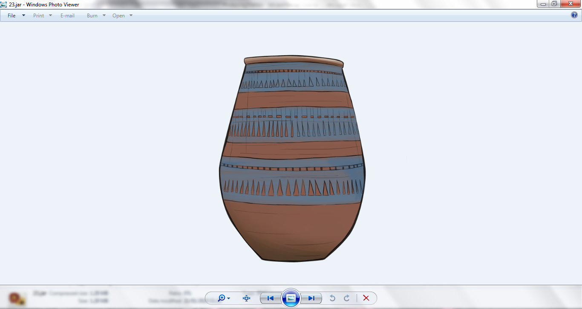People also made small items such as jewellery and tools in their own homes. People had to be very self-sufficient in ancient Egypt – if you needed something, you often had to make it yourself!

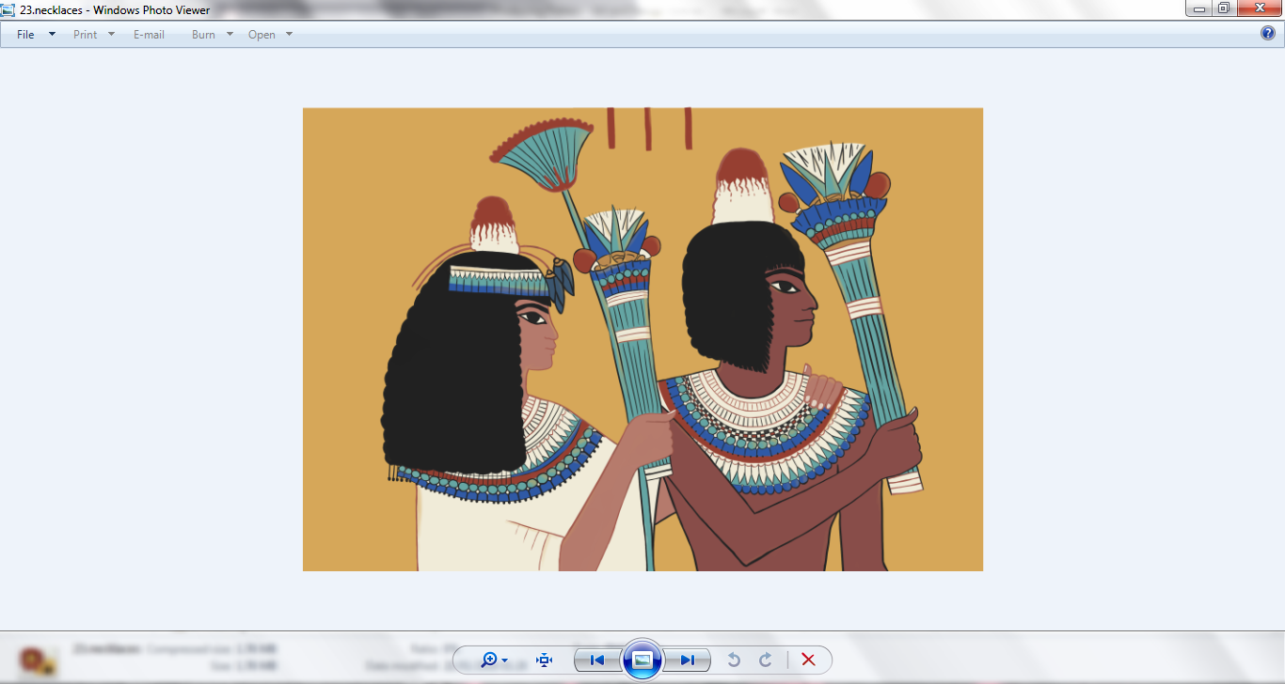

**Art and Design Challenge!**

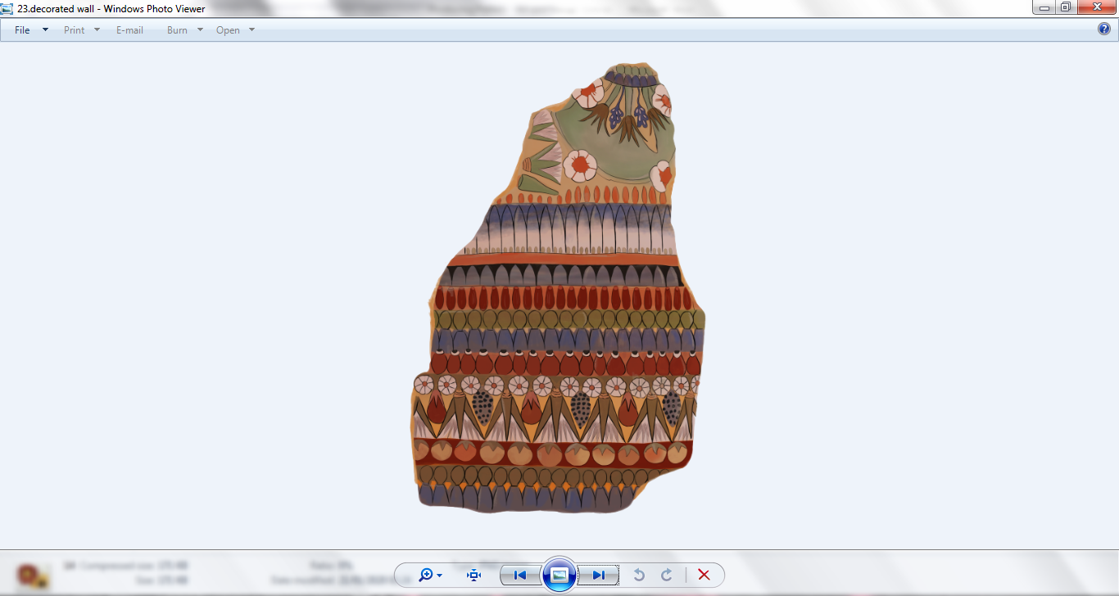A pattern is made up of a repeated design of colours and shapes.

Lots of the patterns created by the artists and craftsmen at Amarna were symmetrical or had repeating motifs.

What patterns do you see around you in daily life?

What plants, animals, shapes and colours do you like best?

Why not combine your favourite things from nature to make your own special repeating pattern inspired by the designs from ancient Amarna?

You could turn your pattern into a decoration for a pot or a painting for your house!