**Body Maths – Measuring Activity**

Ancient Egyptian measurements were based on parts of the body. A cubit was the most used unit of measurement. A cubit was based on the distance from an adult’s elbow to their fingertips (about 52.5 cm).

A palm measured 7.5cm, the distance from the edge of your index finger to the edge of your little finger (like a hand but as if the thumb was cut off, ouch!). The width of a finger, just under 2cm, was known as a digit.



This is an ancient Egyptian cubit rod. It is like a ruler. It would be one cubit long (about 52.5 cm) and divided up into 7 palms of 4 digits each, which makes a total of 28 digits. Architects would have used cubit rods when planning large buildings – like the temples at ancient Amarna!

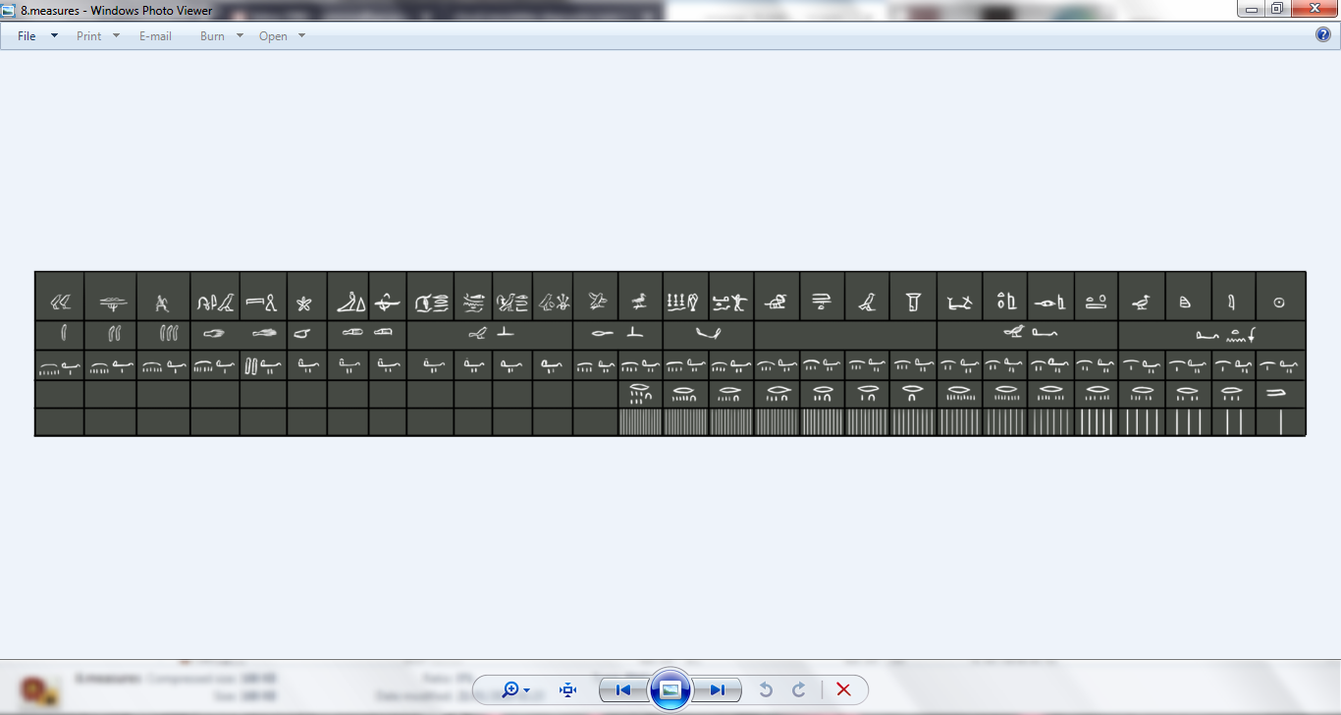

Did you know people still measure things with parts of the body in many countries around the world today? A modern foot is 30cm, about the length of an adult man’s foot. This measurement was probably first used by the ancient Greeks!

**Measuring Challenge!**

Can you measure the things around you using ancient Egyptian measurements?

How tall are you in cubits, palms and digits?

How wide is the room you are in?

What else can you find to measure?

Can you convert your different measurements into mm, cm and m?