**Baking Bread and Brewing Beer - Food Science Activity**

For many ancient Egyptians, life was focused on farming. Cereal crops like wheat and barley were needed to make the most important food and drink - bread and very weak beer! Everyone in ancient Amarna from the King to the poorest families would have had these two items with their meals.

Bread and beer were important offerings to the gods at temples. At ancient Amarna, there were huge bakeries next to the Great Aten Temple which produced bread for the sun god. Loaves of bread and jars of beer were also needed for the afterlife. Sometimes they were put inside tombs, or scenes of baking bread were painted on tombs walls.



Bread is still one of the most widely eaten foods around the world. The main ingredient is normally wheat. There are several kinds of wheat. Today, one type is used to make bread and a different variety is used to make pasta. The ancient Egyptians used another sort of wheat, called emmer wheat, which is hardly grown today. This type has a tough casing around the edible grain that takes a lot of hard work to remove. The ancient Egyptians did this by pounding the grain with a special wooden tool in a large stone bowl to break up the casing, then separating out the grains. After that, they ground the grains of wheat with large stones to make flour.

Once the flour is ready, water then has to be added to create dough. Lot of other ingredients can also be added for flavour, like seeds and oil. Most ancient and modern Egyptian bread is a type of flat bread. This is because it is made without yeast.

Yeast is a special kind of edible fungus that makes bread rise and gives it a special taste. Yeast was added to some ancient Egyptian bread, but was not always used.



Bread has to be baked before it is eaten. In ancient Egypt, bread was sometimes cooked over an open fire or on slabs of stone placed over the flames. At ancient Amarna many houses had dome-shaped ovens. The ovens were made from fired clay.

They didn’t have electricity in ancient Egypt: to heat their ovens they had to build a fire inside. Once the oven wall was really hot the remains of the fire would be carefully removed.

Next, the inside of the oven would be quickly wiped with a damp brush or cloth to get rid of the soot. While one person was doing this job, someone else would be making lots of balls of dough. The balls were then slightly flattened. The bottom of the dough was rubbed with water or milk and stuck onto the hot inner wall of the oven. The leftover heat from the fire would make the bread cook. The bread was ready once it began to lift away from the sides of the oven and the special aroma started to fill the air!

**Cookery Challenge!**

Why not try making your own ancient Egyptian bread? Make sure you ask an adult to help you!

This recipe makes enough for four small, fist-sized loaves or one big one.

Mix together in a large bowl:

- 250g plain flour

- 180ml of warm water

- Pinch of salt

- 5g yeast (5g is normally the amount in one small packet. The ancient Egyptians did not have sachets of yeast. They probably saved some dough with yeast each time they made bread, so the next mixture would have yeast in it. Because yeast is alive it can grow and multiply in the new dough)

You will also need:

- Small cotton cloth (clingfilm will also work but they didn’t have this in ancient Egypt!)

Knead the mixture in the bowl for at least 5 minutes, stretching it out and pressing it down again with your hands. If it seems very wet, add a little more flour. If it seems too dry, add a splash more water.

Cover the bowl with a small cotton cloth and leave the mixture to rise somewhere a little bit warm (not in the fridge!) for 1-2 hours until it has doubled in size. The surface might also have cracked a little.

Knead the dough again and shape it. You might want to split it up into lots of smaller loaves, or make one big one. Ancient Egyptian bread was often round or triangular. Sometimes it was even shaped like a fish, animal or human body. You could try this and see how it comes out! Lay out your shapes on a greased baking sheet and let them sit for another hour to rise again.

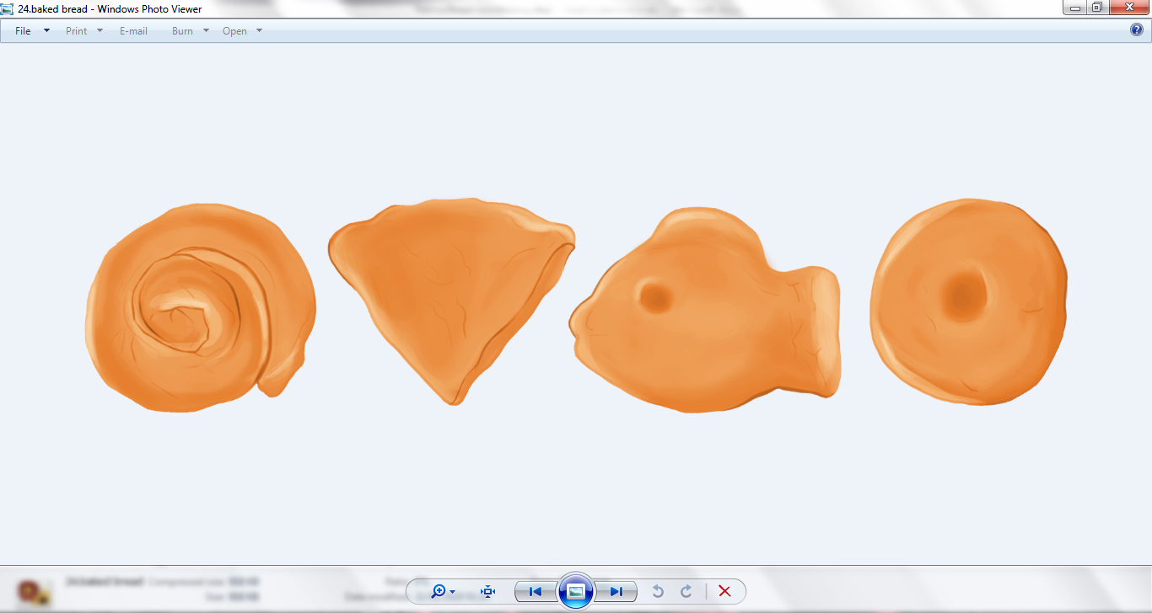

Now your bread is ready for the oven. Don’t worry if you don’t have a clay oven. An electric or gas oven will work too! Make sure the oven is good and hot (220C/400F degrees is about the right temperature). Depending on the size of your loaf, it will take a different amount of time to cook. You’ll know it is ready once it has risen, turned a golden-brown colour and is no longer squashy to touch. Get an adult to help you check your bread is ready so you don’t burn yourself!

We don’t know exactly what people would have eaten with their bread – perhaps nothing if they were very poor or wanted a quick meal! For a main meal, they might have eaten vegetables like onions, spinach, carrots or lentils with their bread, or fish from the Nile. If they were wealthier, they might have had meat from goats or cattle.