Family Tree and History Research Worksheet

This worksheet is about family trees and historical research.
On the next page, you can find the family tree for Akhenaten who was the pharaoh (king) of Egypt more than 3000 years ago!
He ruled the country for less than 20 years but was very important as he changed the religion of Ancient Egypt and built a brand new capital city (see What and where is Amarna information sheet and the Timeline of Egypt information sheet for more details).

Look on the next page. A family tree shows the relationships between people in the same family. Can you find Akhenaten in the middle of the family tree? His Mum and Dad are shown above him. They are King Amenhotep III and Queen Tiye. His wife is shown to his right. Her name was Nefertiti. His children are show below.

King Amenhotep III and Queen Tiye
(parents of Akhenaten)

King Akhenaten (known as Amenhotep IV when he was young) with Queen Nefertiti
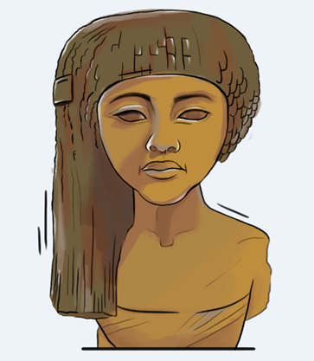

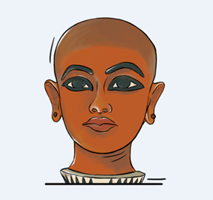
Akhenaten and Nefertiti’s six
daughters: Meritaten,
Meketaten, Ankhesenpaaten,
Nefernefruaten-tasherit,
Neferfeferura and Setepenra

Akhenaten’s son, Tutankhamun. The mother of Tutankhamun is not known. It may have been Nefertiti or perhaps one of Akhenaten’s other wives (he had more than one, but Nefertiti was the most important).
History Research Questions

1. What can you find out about Nefertiti?

How do we know what she looked like?

Are there any famous monuments or artefacts (objects) connected to her?

Did she live to an old age?

Where can you go to see Nefertiti today?

Why do you think she is still so famous?

Can you find any examples of Nefertiti’s image that are used in modern
advertising or company logos?

What other powerful royal women can you find from ancient Egypt?

2. An important invention from Ancient Egypt is called a ‘shaduf’.

Can you find out what a shaduf was?

What was it made from? How did it work?

Is it similar to anything we use today?

Can you find other ancient inventions from Egypt?

TIP! Some good places to start researching these questions are museums, libraries and the internet. Maybe you can even ask an archaeologist!

